**ASSIGNMENTS ON DIGITAL MARKETING**

**NAME:** POOVARASAN.M

**DEPARTMENT:** B.E-ELECTRONICS AND COMMUNICATION ENGINEERING

**COLLEGE:** 8151 DHANALAKSHMI SRINIVASAN INSTITUTE OF TECHNOLOGY

**NAANMUDHALVAN COURSE:** DIGITAL MARKETING

**NM ID :**58892FF186DC4C8ACBC47C7A8810210B

**ASSIGNMENTS 1:**

Create a blog or website using blog spot and word press .

Customize

The theme design and post new article with 500 words.

<https://wordpress.com/domains/manage/hypervreality.wordpress.com>

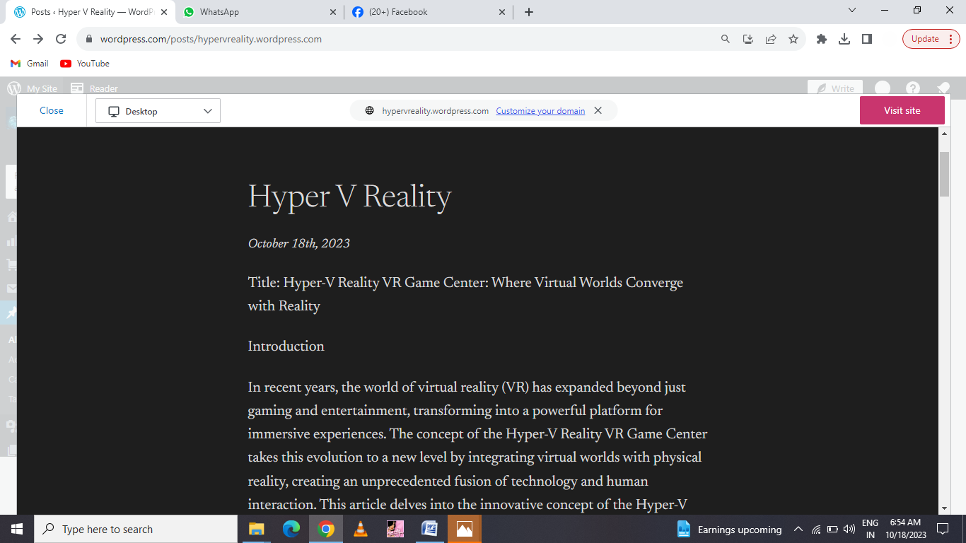

**ASSIGNMENTS 2:**

Create a new Facebook business page and post one social media poster for your brand

<https://www.facebook.com/profile.php?id=61550477780381&mibextid=ZbWKwL>

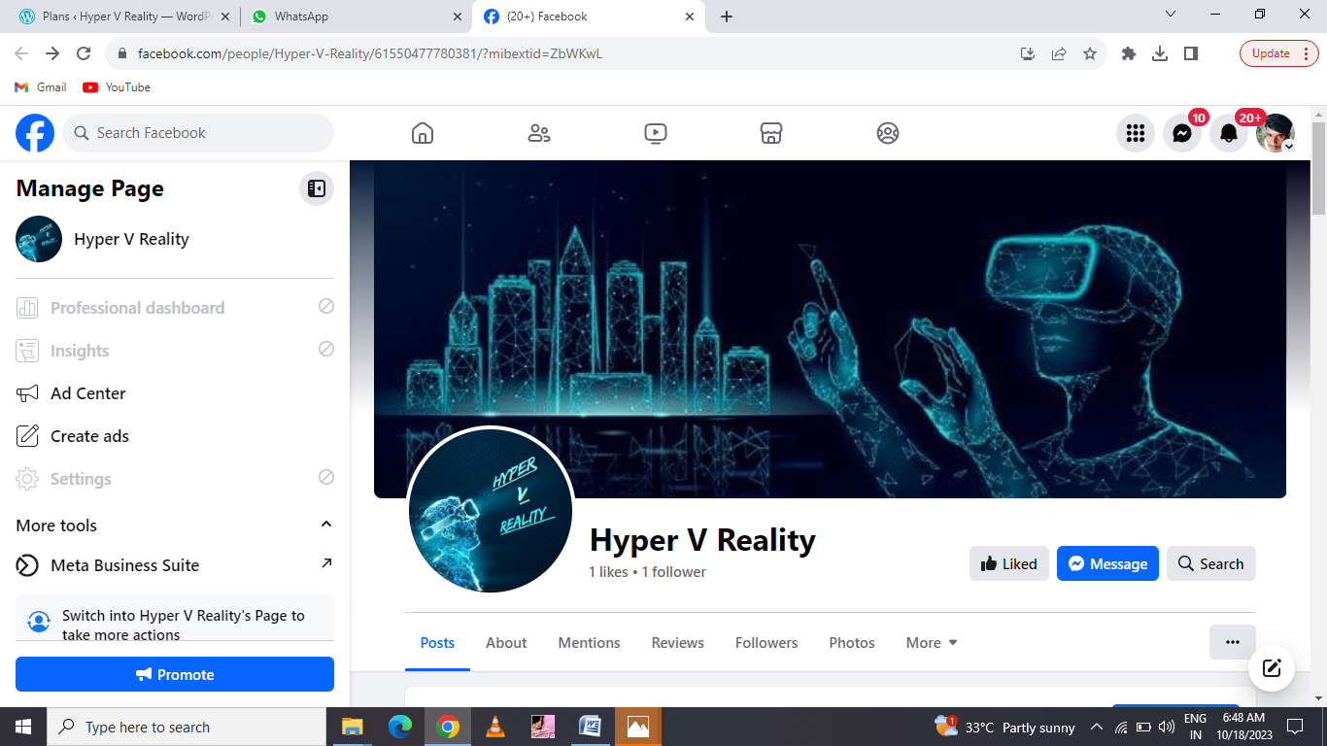

**ASSIGNMENT 3:**

Create and design a social media advertisement poster

using canva

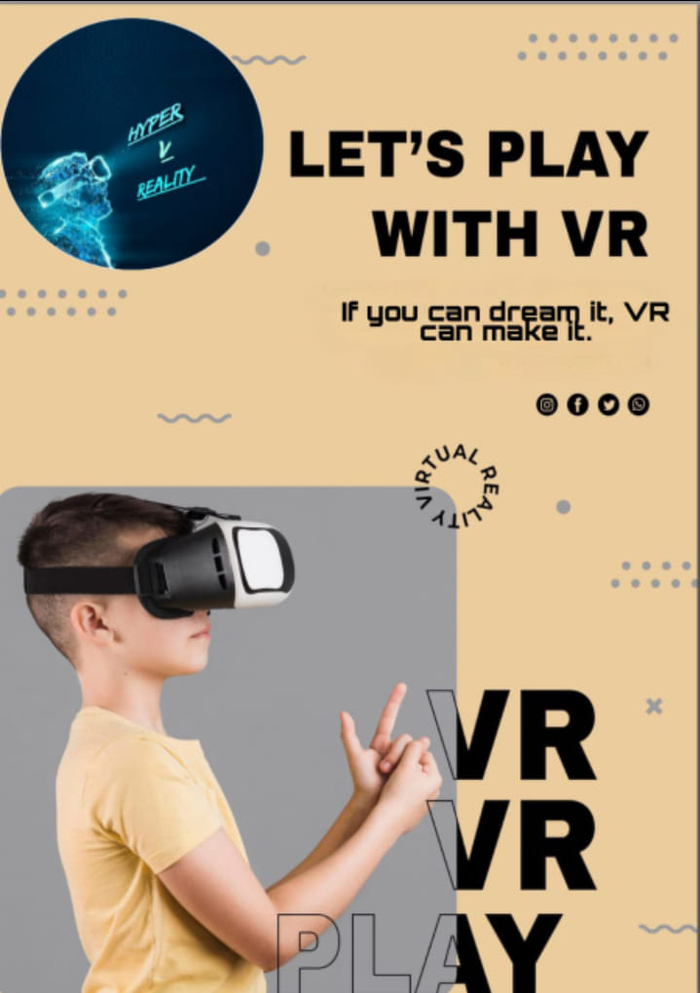

**ASSIGNMENT 4:**

4.Create email newsletter design using Mailchimp or canva tool.

